- Experiment: Selective Inhibition of IL-6 Trans-signaling and Preservation of Classical Signaling by STAR-Trap Macrophages
- Time: 2026.08.12-2026.08.31
- Member: Qichang Liu, Kaili Jin, Zhangdong Liu, Yuxuan Wang, Xinru Yuan
- Materials: IL-6, sIL-6Rα, IL-6/sIL-6Rα complex, WT-Mφ, STAR-Trap macrophages (THP-1-derived), HUVEC cells (for trans-signaling assay), U266 cells (for classical signaling assay), Tocilizumab, complete medium (RPMI-1640 with 10% FBS and 1% penicillin-streptomycin), FACS buffer (PBS with 1% FBS), fixation/permeabilization kit, antibodies against pSTAT3, MCP-1, and ICAM-1.
- Method:
- Inhibition of IL-6 trans-signaling:
- The following experimental groups were set up:
Group | Description
Group 1 | complex
Group 2 | complex + WT-Mφ
Group 3 | complex + STAR-Trap
- Different macrophages were incubated with IL-6/sIL-6Rα complex.
- Cell-free supernatants were collected.
- The supernatants were added to the HUVEC cell culture system.
- IL-6 trans-signaling in endothelial cells was detected by measuring pSTAT3, MCP-1, and ICAM-1.
- Preservation of IL-6 classical signaling:
- U266 cells were used for the classical signaling assay. The expression of mIL-6Rα and gp130 on U266 cells was confirmed by flow cytometry prior to the experiment.
- The following experimental groups were set up:
Group | Description
Group 1 | IL-6
Group 2 | IL-6 + WT-Mφ
Group 3 | IL-6 + STAR-Trap
Group 4 | IL-6 + Tocilizumab (positive control for classical signaling inhibition)
- Different macrophages were incubated with IL-6.
- Cell-free supernatants were collected.
- The supernatants were added to the U266 cell culture system.
- IL-6 classical signaling in U266 cells was detected by measuring pSTAT3, MCP-1, and ICAM-1.
- Flow cytometric analysis:
- Cells were harvested and washed twice with FACS buffer.
- For pSTAT3 detection, cells were fixed and permeabilized (including nuclear permeabilization) using a Foxp3/Transcription Factor Staining Buffer Set or equivalent, followed by intracellular staining with anti-pSTAT3 antibody for 30 min at 4 ℃ in the dark.
- For ICAM-1 detection, cells were stained with the corresponding antibody on the cell surface according to the standard staining protocol.
- For MCP-1 detection, the culture supernatant was collected and measured by ELISA or CBA (no permeabilization required).
- Flow cytometry was performed, and the mean fluorescence intensity (MFI) and positive cell percentages were recorded for each group.
- Result:
- Inhibition of IL-6 trans-signaling: The expression levels of pSTAT3, MCP-1, and ICAM-1 in endothelial cells treated with supernatants from different groups are summarized below.
Group | pSTAT3 | MCP-1 | ICAM-1
complex | ↑↑↑ | ↑↑↑ | ↑↑↑
complex + WT-Mφ | ↑↑↑ | ↑↑↑ | ↑↑↑
complex + STAR-Trap | ↓↓↓ | ↓↓↓ | ↓↓↓
These results indicate that STAR-Trap macrophages selectively inhibit IL-6 trans-signaling.
- Preservation of IL-6 classical signaling: The expression levels of pSTAT3, MCP-1, and ICAM-1 in U266 cells treated with supernatants from different groups are summarized.
Group | pSTAT3 | MCP-1 | ICAM-1
IL-6 | ↑↑↑ | ↑↑↑ | ↑↑↑
IL-6 + WT-Mφ | ↑↑↑ | ↑↑↑ | ↑↑↑
IL-6 + STAR-Trap | ↑↑↑ | ↑↑↑ | ↑↑↑
IL-6 + Tocilizumab | ↓↓↓ | ↓↓↓ | ↓↓↓
These results indicate that STAR-Trap macrophages preserve IL-6 classical signaling, as opposed to the pan-inhibition observed with Tocilizumab.
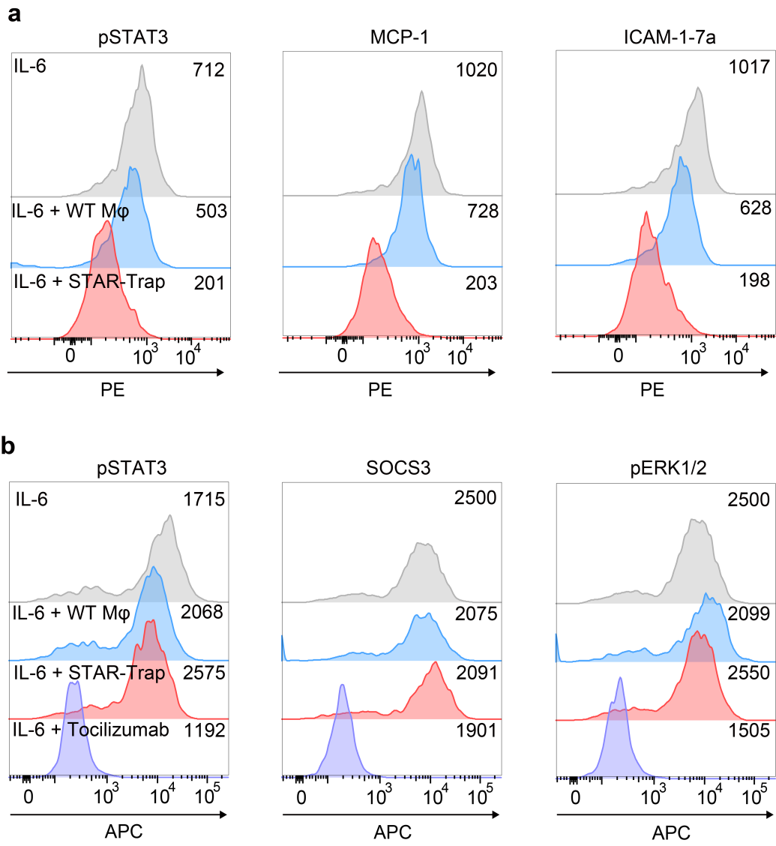
Figure 1. STAR-Trap attenuates IL-6 trans-signaling while preserving classical signaling.
a, Representative flow-cytometry histograms showing IL-6 trans-signaling responses. The IL-6/sIL-6Rα complex was incubated alone or preincubated with WT or STAR-Trap. After removal of the macrophages, the resulting cell-free supernatants were applied to gp130-positive responder cells with low or undetectable mIL-6Rα expression. Intracellular pSTAT3 and the downstream inflammatory markers MCP-1 and ICAM-1 were subsequently measured. Grey, IL-6/sIL-6Rα complex alone; blue, complex preincubated with WT macrophages; red, complex preincubated with STAR-Trap. b, Representative flow-cytometry histograms showing classical IL-6 signaling responses. Free IL-6 was incubated alone or preincubated with WT or STAR-Trap, and the resulting cell-free supernatants were applied to responder cells expressing both mIL-6Rα and gp130. Intracellular pSTAT3, SOCS3 and pERK1/2 were measured, with Tocilizumab included as an IL-6R-blocking control. Grey, IL-6 alone; blue, IL-6 preincubated with WT macrophages; red, IL-6 preincubated with STAR-Trap; purple, Tocilizumab-treated control. Numbers indicate the median fluorescence intensity of the corresponding cell populations.

